Application for Education and Development

About this form
This document will allow you to collect your thoughts about the programme of study you would like to develop and helps us identify how we can best support you.
Title of course: Click here to enter text. Application Date: Click here to enter text.

About your team

Who is involved in delivering or developing your programme?
Your name | Click here to enter text. | Your position | Click here to enter text.
Your email | Click here to enter text. | Your phone number/s | Click here to enter text.
Course Sponsor [Who wants you to develop this course?] | Click here to enter text. | Sponsor’s position | Click here to enter text.
Manager [If not sponsor] | Click here to enter text. | Manager’s position | Click here to enter text.
Subject Matter Expert [If not you] | Click here to enter text. | Content Approval Person[if not sponsor or SME] | Click here to enter text.

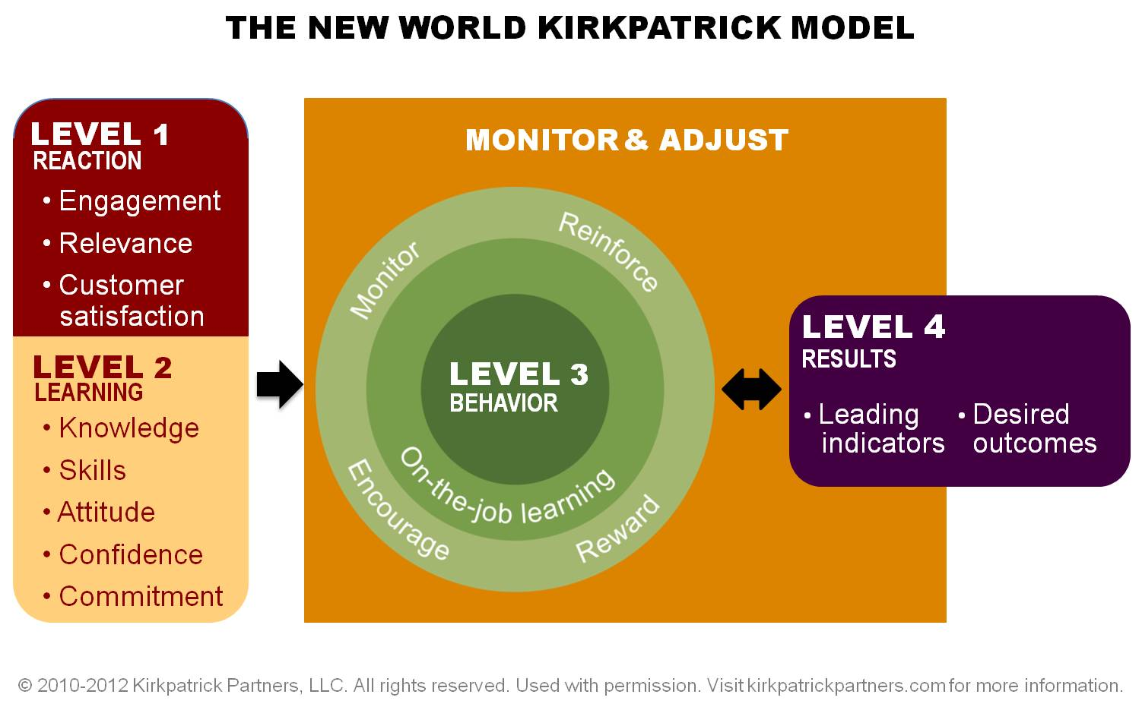
Education needs to be designed with the desired outcomes in mind. You need to be clear about what is taught will be used on the job and this will contribute the CDHB and WCDHB overall goal of improved patient care.

Section one: about your programme
Briefly tell us about your learning activity, programme,
Note: Is this educational activity planned to support any nursing activity that is outside the normal scope of clinical practice? If so, then it MUST go through the Credentialing Committee first.
What does this programme aim to achieve? (level three)
Click here to enter text.

What difference will we notice in the workplace? (level three)
Click here to enter text.
What will be the skills, knowledge or attributes of a person once they have completed the course? (level two)
Click here to enter text.

How will you know (how will you evaluate) if staff have applied the learning to the workplace? (level four)
Click here to enter text.

Is the programme run in any other DHB? Can we adapt it for the CDHB? If course is available online at other DHBs, could CDHB access the materials? | Maximum and Minimum Numbers of participants (e.g 14-20 people per course/ number of courses)
Click here to enter text. | Click here to enter text.
How will you deliver your programme? E.g. Online learning, Self-directed workbooks, Face to face | List your teaching methods of delivery? E.g. case studies Video, Group work, simulation.
Click here to enter text. | Click here to enter text.
What (if any) risks are there to the CDHB if the programme is not available and/or participation not recorded? (E.g. patient/consumer safety, compliance issues etc, Is the programme compulsory training for our DHB?).
Click here to enter text.

Who else in health could potentially use this programme?

What is the risk to successful implementation of the programme? How will you manage this risk?
Click here to enter text.

Please list who you have consulted with and data accessed to assess learning needs
Click here to enter text.

How does the course contribute to the goals of the Canterbury and West Coast Health System?
Click here to enter text.

Additional comments

Online learning/blended learning option
If there is an online component please complete this additional section.

If an online component, how would you like the course to be developed?
 | Do you have online authoring expertise?
 | Do you have Articulate authoring expertise?
 | Do you have an Articulate license?
Other authoring software – please specify the software  Click here to enter text. | Do you have expertise in this software in your team?
Who in your team who will be responsible for keeping the content up to date?
(e.g. someone who can ensure that the course is reviewed at least once every year to keep it up to date)
Click here to enter text.
How is the training currently delivered? What sort of course material already exists?
(e.g., Course handouts, Power Point, not delivered at the moment etc).
Click here to enter text.

If the course is moving from purely face to face to online delivery, what is the benefit in doing this?
(e.g. cost saving, staff time, wider geographical area etc)
Click here to enter text.

What about assessments and results? (Tick any that apply to you)
I

How much time do you have available to contribute to the development of the course?
Click here to enter text.

NOTE: Section one and your programme needs to be submitted to the relevant Education Development Committee for approval before you complete section two of this application.

Section two: design, delivery and budget (level one)
TO BE COMPLETED ONCE SECTION ONE APPROVED.
Title:Click here to enter text. | Date: Click here to enter text.
What resources are required to develop and deliver this educational activity?
Click here to enter text.

Length of session, state the time allocated for the whole of the educational activity.
Click here to enter text.

List pre reading or prerequisites that are required to be completed prior to attendance or completing this educational activity.
Click here to enter text.

Lesson Plan
Click here to enter text.

What are the learning outcomes? What do you want them to know or to do by the end of the programme?
e.g. how infection is spread in hospitals)
[e.g. cleanse hands in correct way]
Click here to enter text.Please attach the lesson plan

How will you incorporate the continuum of care into this programme?
Click here to enter text.

Method of evaluation: How will you assess their knowledge, skills (were the skills taught easily transferable to the workplace)?
e.g. exemplar, care plan, pre/post course test, clinical skill activity, performance review,
Click here to enter text.

How will you determine that the learning is applied to clinical practice (attitude)?
e.g. Audit, clinical incidents, feedback, assessment
Click here to enter text.

What sort of print resources do you think you would like/how will these be produced?
E.g. Manuals, handouts.
Click here to enter text.

Document Control
Title: | Click here to enter text.
 | Name | Title | Contact Details
Applicant | Click here to enter text. | Click here to enter text. | Click here to enter text.
Clinical sponsor | Click here to enter text. | Click here to enter text. | Click here to enter text.
Education Advisor (1) | Click here to enter text. | Click here to enter text. | Click here to enter text.
Education Advisor (2) | Click here to enter text. | Click here to enter text. | Click here to enter text.
Part 1 –Demonstrating Education Need
Submission Date: | Click here to enter text.
Recommendation by Education Development Committee | Click here to enter text.
Credentialing required? | Click here to enter text.
Part 2 – Design, Delivery and Budget Consideration
Submission Date: | Click here to enter text.
Committee Development Approval | Click here to enter text. | Authorised by | Click here to enter text.
Part 3 – Congratulatory Letter
Entered on Calendar | Click here to enter text.
Review Date | Click here to enter text.
Comments
Click here to enter text.

