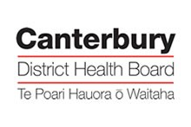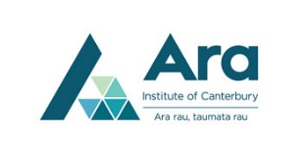

Managing Potential Conflicts of Interest Related to Nursing Students on CDHB Clinical Placements

- All nursing students are advised to disclose any potential conflict of interest to the academic institution prior to clinical placement allocation e.g. health or personal relationships.

- If a clinical area has concerns in relation to the appropriateness of an individual student placement within their service e.g. recent consumer or employee of the service or non-disclosed conflict of interest, please contact the Ara/Otago Clinical Manager and the DEU Nurse Educator (note within the SMHS the NC for the area will be the first point of contact).

- In the event of a nursing student being a consumer of any clinical service during student clinical placement no nursing student from their cohort will be involved in their care. Where possible the students will remove themselves from any discussions related to their student colleague i.e. handover and MDT meetings. Students will not be assigned to work alongside the nurse allocated to the care of their student colleague but will remain in the clinical area.

CDHB DEU Nurse Educator
Kirsten Erickson Kirsten.Erickson@cdhb.health.nz 021 512 805

Ara Clinical Managers
Rose Whittle Rose.Whittle@ara.ac.nz Ara after Hours Emergency Phone 027 540 8074
Kate Pugh kate.pugh@ara.ac.nz

Otago University Clinical Manager Otago after Hours Emergency Phone 021 364 385

